Коллекція 1:

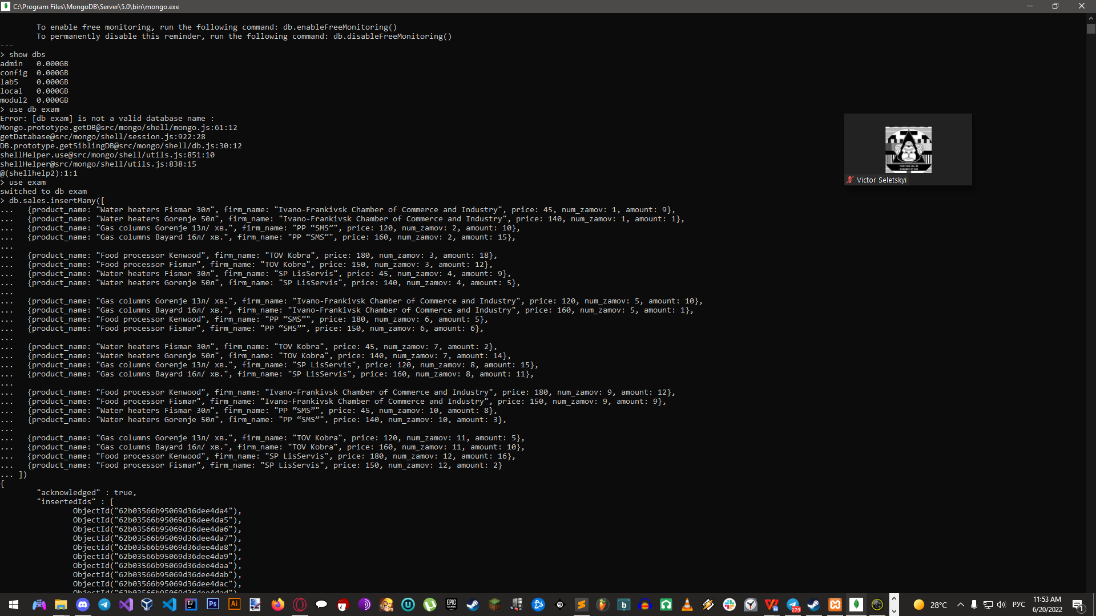

db.sales.insertMany([

{product_name: "Water heaters Fismar 30л", firm_name: "Ivano-Frankivsk Chamber of Commerce and Industry", price: 45, num_zamov: 1, amount: 9},

{product_name: "Water heaters Gorenje 50л", firm_name: "Ivano-Frankivsk Chamber of Commerce and Industry", price: 140, num_zamov: 1, amount: 1},

{product_name: "Gas columns Gorenje 13л/ хв.", firm_name: "PP “SMS”", price: 120, num_zamov: 2, amount: 10},

{product_name: "Gas columns Bayard 16л/ хв.", firm_name: "PP “SMS”", price: 160, num_zamov: 2, amount: 15},

{product_name: "Food processor Kenwood", firm_name: "TOV Kobra", price: 180, num_zamov: 3, amount: 18},

{product_name: "Food processor Fismar", firm_name: "TOV Kobra", price: 150, num_zamov: 3, amount: 12},

{product_name: "Water heaters Fismar 30л", firm_name: "SP LisServis", price: 45, num_zamov: 4, amount: 9},

{product_name: "Water heaters Gorenje 50л", firm_name: "SP LisServis", price: 140, num_zamov: 4, amount: 5},

{product_name: "Gas columns Gorenje 13л/ хв.", firm_name: "Ivano-Frankivsk Chamber of Commerce and Industry", price: 120, num_zamov: 5, amount: 10},

{product_name: "Gas columns Bayard 16л/ хв.", firm_name: "Ivano-Frankivsk Chamber of Commerce and Industry", price: 160, num_zamov: 5, amount: 1},

{product_name: "Food processor Kenwood", firm_name: "PP “SMS”", price: 180, num_zamov: 6, amount: 5},

{product_name: "Food processor Fismar", firm_name: "PP “SMS”", price: 150, num_zamov: 6, amount: 6},

{product_name: "Water heaters Fismar 30л", firm_name: "TOV Kobra", price: 45, num_zamov: 7, amount: 2},

{product_name: "Water heaters Gorenje 50л", firm_name: "TOV Kobra", price: 140, num_zamov: 7, amount: 14},

{product_name: "Gas columns Gorenje 13л/ хв.", firm_name: "SP LisServis", price: 120, num_zamov: 8, amount: 15},

{product_name: "Gas columns Bayard 16л/ хв.", firm_name: "SP LisServis", price: 160, num_zamov: 8, amount: 11},

{product_name: "Food processor Kenwood", firm_name: "Ivano-Frankivsk Chamber of Commerce and Industry", price: 180, num_zamov: 9, amount: 12},

{product_name: "Food processor Fismar", firm_name: "Ivano-Frankivsk Chamber of Commerce and Industry", price: 150, num_zamov: 9, amount: 9},

{product_name: "Water heaters Fismar 30л", firm_name: "PP “SMS”", price: 45, num_zamov: 10, amount: 8},

{product_name: "Water heaters Gorenje 50л", firm_name: "PP “SMS”", price: 140, num_zamov: 10, amount: 3},

{product_name: "Gas columns Gorenje 13л/ хв.", firm_name: "TOV Kobra", price: 120, num_zamov: 11, amount: 5},

{product_name: "Gas columns Bayard 16л/ хв.", firm_name: "TOV Kobra", price: 160, num_zamov: 11, amount: 10},

{product_name: "Food processor Kenwood", firm_name: "SP LisServis", price: 180, num_zamov: 12, amount: 16},

{product_name: "Food processor Fismar", firm_name: "SP LisServis", price: 150, num_zamov: 12, amount: 2}

])

Коллекція 2:

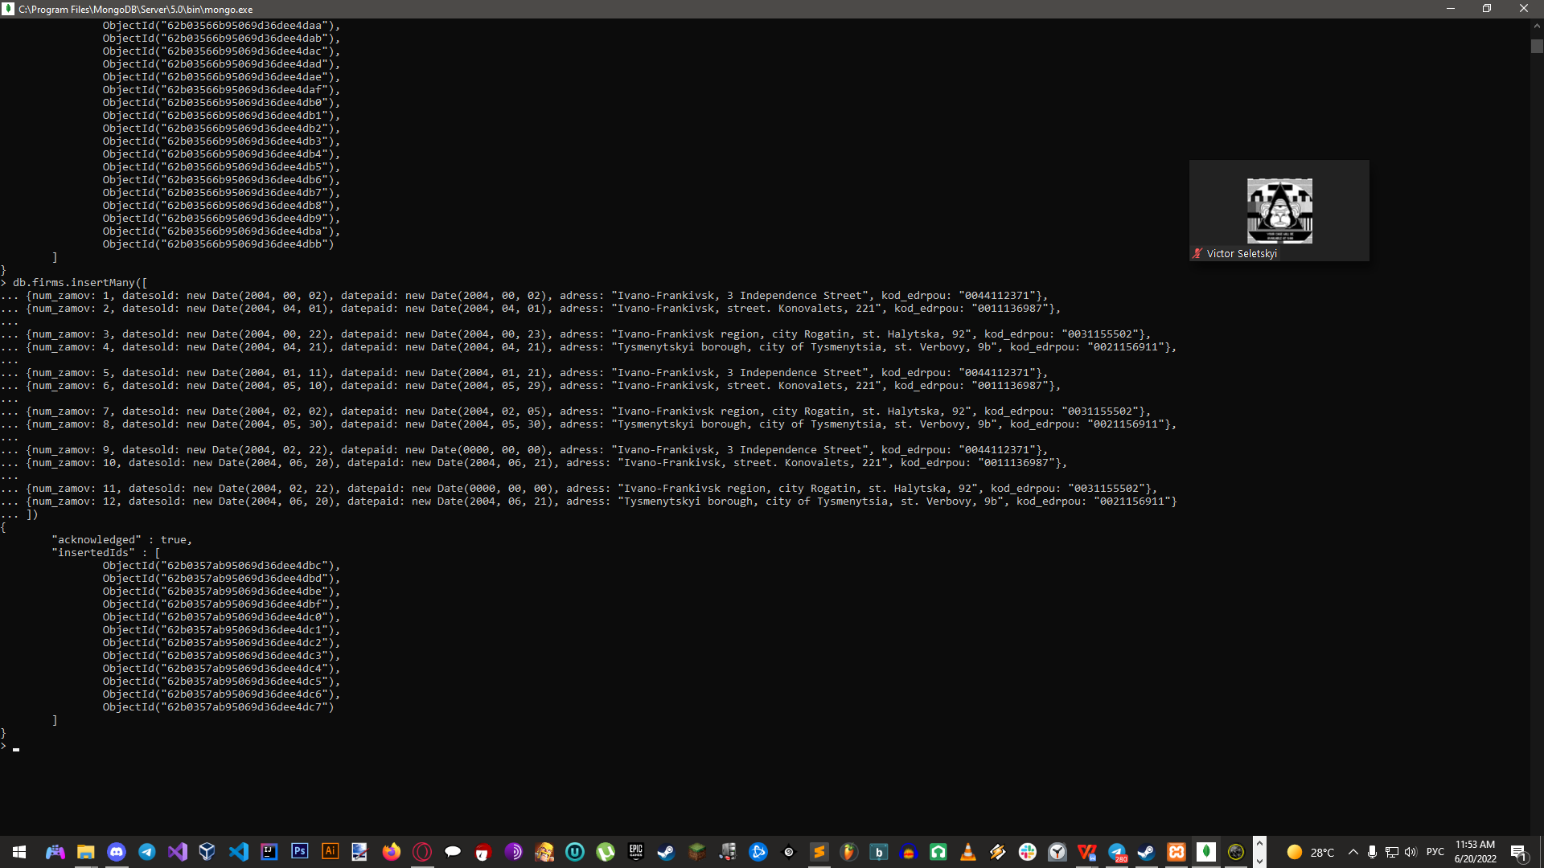

db.firms.insertMany([

{num_zamov: 1, datesold: new Date(2004, 00, 02), datepaid: new Date(2004, 00, 02), adress: "Ivano-Frankivsk, 3 Independence Street", kod_edrpou: "0044112371"},

{num_zamov: 2, datesold: new Date(2004, 04, 01), datepaid: new Date(2004, 04, 01), adress: "Ivano-Frankivsk, street. Konovalets, 221", kod_edrpou: "0011136987"},

{num_zamov: 3, datesold: new Date(2004, 00, 22), datepaid: new Date(2004, 00, 23), adress: "Ivano-Frankivsk region, city Rogatin, st. Halytska, 92", kod_edrpou: "0031155502"},

{num_zamov: 4, datesold: new Date(2004, 04, 21), datepaid: new Date(2004, 04, 21), adress: "Tysmenytskyi borough, city of Tysmenytsia, st. Verbovy, 9b", kod_edrpou: "0021156911"},

{num_zamov: 5, datesold: new Date(2004, 01, 11), datepaid: new Date(2004, 01, 21), adress: "Ivano-Frankivsk, 3 Independence Street", kod_edrpou: "0044112371"},

{num_zamov: 6, datesold: new Date(2004, 05, 10), datepaid: new Date(2004, 05, 29), adress: "Ivano-Frankivsk, street. Konovalets, 221", kod_edrpou: "0011136987"},

{num_zamov: 7, datesold: new Date(2004, 02, 02), datepaid: new Date(2004, 02, 05), adress: "Ivano-Frankivsk region, city Rogatin, st. Halytska, 92", kod_edrpou: "0031155502"},

{num_zamov: 8, datesold: new Date(2004, 05, 30), datepaid: new Date(2004, 05, 30), adress: "Tysmenytskyi borough, city of Tysmenytsia, st. Verbovy, 9b", kod_edrpou: "0021156911"},

{num_zamov: 9, datesold: new Date(2004, 02, 22), datepaid: new Date(0000, 00, 00), adress: "Ivano-Frankivsk, 3 Independence Street", kod_edrpou: "0044112371"},

{num_zamov: 10, datesold: new Date(2004, 06, 20), datepaid: new Date(2004, 06, 21), adress: "Ivano-Frankivsk, street. Konovalets, 221", kod_edrpou: "0011136987"},

{num_zamov: 11, datesold: new Date(2004, 02, 22), datepaid: new Date(0000, 00, 00), adress: "Ivano-Frankivsk region, city Rogatin, st. Halytska, 92", kod_edrpou: "0031155502"},

{num_zamov: 12, datesold: new Date(2004, 06, 20), datepaid: new Date(2004, 06, 21), adress: "Tysmenytskyi borough, city of Tysmenytsia, st. Verbovy, 9b", kod_edrpou: "0021156911"}

])